Modular electric deck oven
2 decks composition
Amalfi consists of one or more independent baking chambers and an optional prover or stand. The baking chamber is entirely made of refractory stone with coiled heating elements inside, allowing the perfect heat distribution over the whole surface. This oven is particularly suitable for direct pizza baking, specific for more delicate toppings and recommended for indirect baking on trays. Temperature management is electronic, power control of ceiling and floor is independent. The oven door is hinged at the bottom, with a tempered glass window to check the product during baking. The stand consists of a painted metal structure, while the prover is a stainless steel cabinet equipped with a heating thermostat. The prover can reach the maximum temperature of 149°F, whereas the maximum temperature of the baking chamber is 842°F.

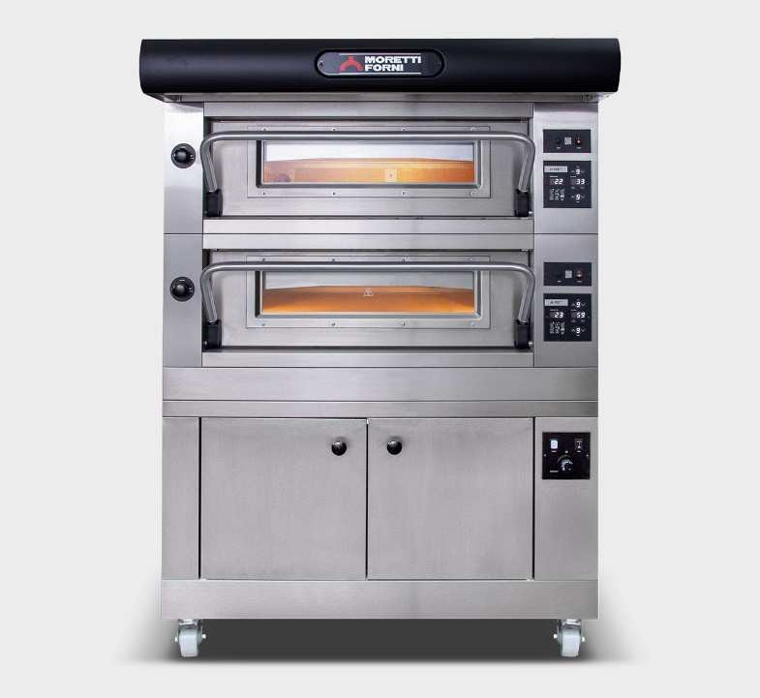

OPERATION
- Heated by spiral heating elements
- Electronic temperature management with independent adjustment of ceiling
and floor
- Maximum temperature reached 842°F
- Continuous temperatures monitoring in baking chamber by thermocouple
- Vapour ducting using manual butterfly valve

CONSTRUCTION
- Structure made in folded stainless steel
- Side panels in painted sheet metal
- Hood in stainless steel
- Steam duct in stainless steel plate
- Stainless steel door, tempered glass
- Refractory top and side structure
- Dual halogen lighting
- Rock wool heat insulation

ACCESSORIES
- Leavening proofer on wheels height 23 1/2”, 31 1/2”
- Stand with wheels height 23 1/2”, 31 1/2”, 37 1/2”
- Spacer element height 11 13/16”
- Additional tray holder guides for compartment and stand
- Self-condensing hood
- Frontless hood

INTERNAL BAKING DIMENSIONS
Internal height 7”
Internal depth 40 1/2”
Internal widht 37 1/4“
Baking surface 10,8ft2
STANDARD EQUIPMENT
- 20 customisable programs
- Timer
- Economiser
- Independent maximum temperature safety device

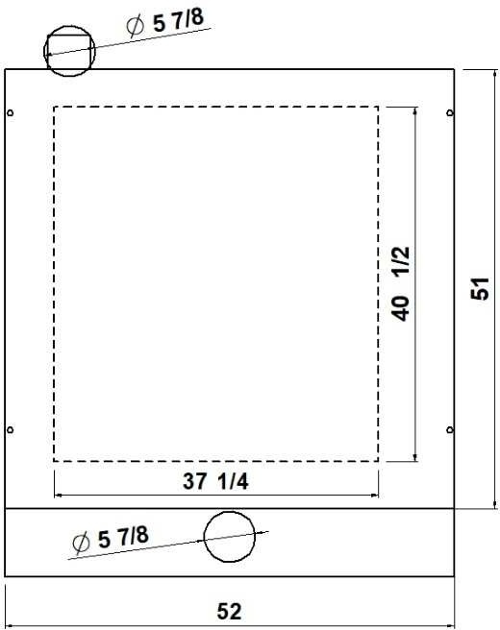
TOP VIEW

1 baking chamber height 7”
(assembled with stand height 37 1/2”)

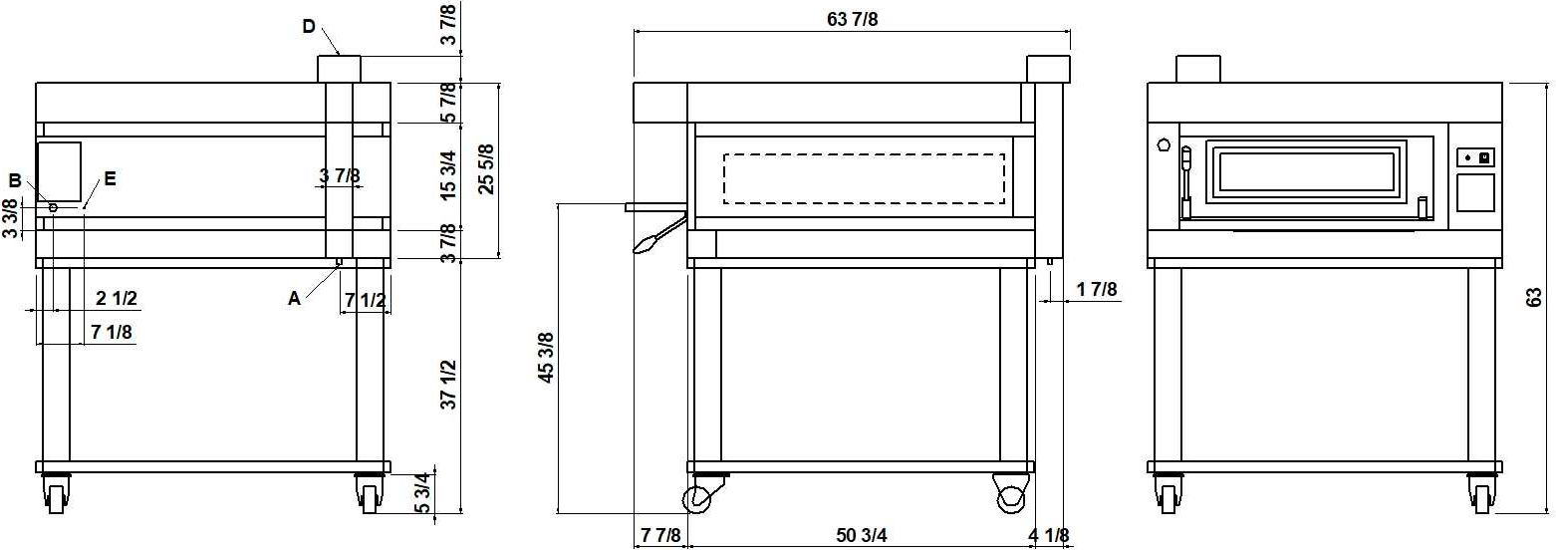
REAR VIEW RIGHT SIDE VIEW FRONT VIEW

NOTE: The dimensions indicated in the views are in inches.

A  Ø 1/2”  condensate exhaust | B  fairleads | D  Ø 5 7/8”  steam exhaust | E  M6  equipotential screws

DIMENSIONS
External height 25 5/8” (650mm) External depth 51” (1290mm)
External width 52” (1320mm)
Weight 602lb (273kg)

TOTAL BAKING CAPACITY
Tray 26”x18” (600x400)mm 3
Pizza diameter 12” 9
Pizza diameter 18” 4
SHIPPING INFORMATION
Packed in wooden crate
Height 36” (900mm)
Depth 73” (1851mm)
Width 60” (1520mm)
Weight 713lb (323kg)

When combined with leavening compartment or stand:
Max height 73” (1850mm)
Max weight 973lb (441kg)

FEEDING AND POWER
Standard feeding
A.C. V240 3ph
Feeding on request
A.C. V208 3ph
Frequency 60Hz
Max power 10,5kW/DECK
*Average power cons 5,3kWh Ampère max
25,2A/DECK (V240 3ph)
29,1A/DECK (V208 3ph)
Connecting cable for each chamber
9AWG/DECK
Power supply (optional proofer)
A.C. V(208/240) 1ph 60Hz
Max power 1,8kW
*Average power cons 0,9kWh Conn. Cable 14AWG – Ampère 7,5A
* This value is subject to variation according to the way in which the equipment is used
NOTE: MORETTI FORNI S.P.A. reserves the right to modify the characteristics of the products illustrated in this publication without prior notice

2 baking chambers height 7”
(assembled with proofer height 31 1/2“)

REAR VIEW RIGHT SIDE VIEW FRONT VIEW
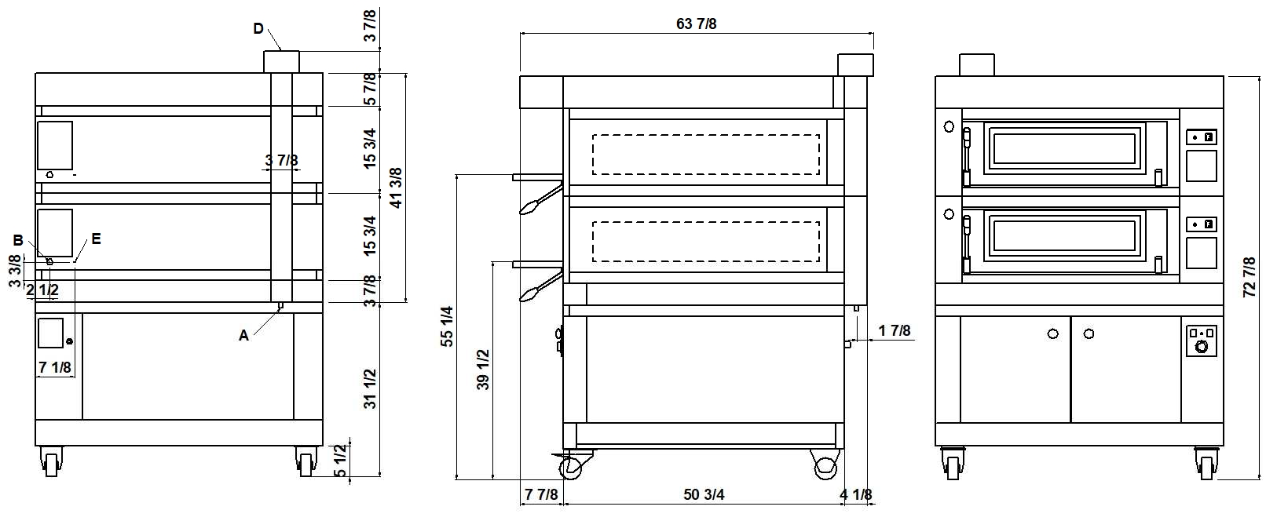
NOTE: The dimensions indicated in the views are in inches.

A  Ø 1/2”  condensate exhaust | B  fairleads | D  Ø 5 7/8”  steam exhaust | E  M6  equipotential screws

DIMENSIONS
External height 41 3/8” (1050mm) External depth 51” (1290mm)
External width 52” (1320mm)
Weight 1028lb (466kg)

TOTAL BAKING CAPACITY
Tray 26”x18” (600x400)mm 6
Pizza diameter 12” 18
Pizza diameter 18” 6
SHIPPING INFORMATION
Packed in wooden crate
Height 51 1/2” (1300mm)
Depth 73” (1851mm)
Width 60” (1520mm)
Weight 1160lb (526kg)

When combined with leavening compartment or stand:
Max height 89” (2250mm)
Max weight 1420lb (644kg)

FEEDING AND POWER
Standard feeding
A.C. V240 3ph
Feeding on request
A.C. V208 3ph
Frequency 60Hz
Max power 10,5kW/DECK
*Average power cons 5,3kWh Ampère max
25,2A/DECK (V240 3ph)
29,1A/DECK (V208 3ph)
Connecting cable for each chamber
9AWG/DECK
Power supply (optional proofer)
A.C. V(208/240) 1ph 60Hz
Max power 1,8kW
*Average power cons 0,9kWh Conn. Cable 14AWG – Ampère 7,5A
* This value is subject to variation according to the way in which the equipment is used
NOTE: MORETTI FORNI S.P.A. reserves the right to modify the characteristics of the products illustrated in this publication without prior notice

3 baking chambers height 7”
(assembled with proofer height 23 1/2”)

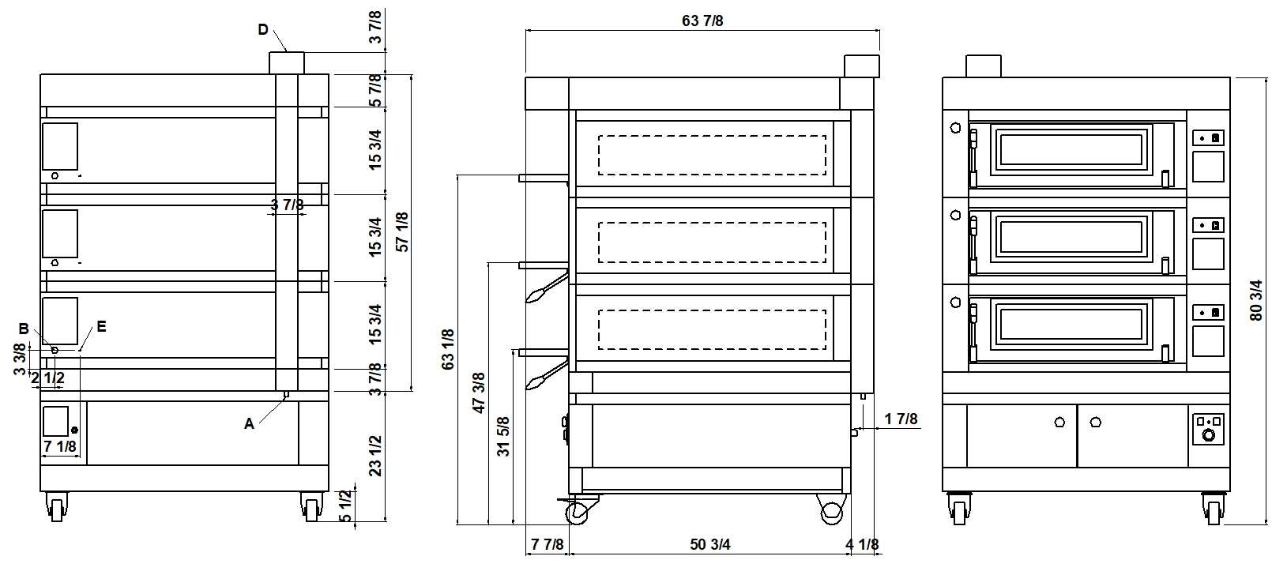
REAR VIEW RIGHT SIDE VIEW FRONT VIEW
NOTE: The dimensions indicated in the views are in inches.

A  Ø 1/2”  condensate exhaust | B  fairleads | D  Ø 5 7/8”  steam exhaust | E  M6  equipotential screws

DIMENSIONS
External height 57 1/8” (1450mm) External depth 51” (1290mm)
External width 52” (1320mm)
Weight 1453lb (659kg)

TOTAL BAKING CAPACITY
Tray 26”x18” (600x400)mm 9
Pizza diameter 12” 27
Pizza diameter 18” 12
SHIPPING INFORMATION
Packed in wooden crate
Height 71” (1800mm)
Depth 73” (1851mm)
Width 60” (1520mm)
Weight 1608lb (729kg)

When combined with leavening compartment or stand:
Max height 109” (2750mm)
Max weight 1868lb (847kg)

FEEDING AND POWER
Standard feeding
A.C. V240 3ph
Feeding on request
A.C. V208 3ph
Frequency 60Hz
Max power 10,5kW/DECK
*Average power cons 5,3kWh Ampère max
25,2A/DECK (V240 3ph)
29,1A/DECK (V208 3ph)
Connecting cable for each chamber
9AWG/DECK
Power supply (optional proofer)
A.C. V(208/240) 1ph 60Hz
Max power 1,8kW
*Average power cons 0,9kWh Conn. Cable 14AWG – Ampère 7,5A
* This value is subject to variation according to the way in which the equipment is used
NOTE: MORETTI FORNI S.P.A. reserves the right to modify the characteristics of the products illustrated in this publication without prior notice

* This value is subject to variation according to the way in which the equipment is used
NOTE: MORETTI FORNI S.P.A. reserves the right to modify the characteristics of the products illustrated in this publication without prior notice
Amalfi C
TECHNICAL DATA

FEEDING AND POWER  (EACH DECK NEEDS TO BE CONNECTED INDEPENDENTLY AND THE LOAD SHOWN BELOW ARE PER DECK) | A.C. V240 3ph 60Hz | Standard feeding | Max power | kW | 10,5
 | A.C. V240 3ph 60Hz | Standard feeding | *Medium cons/hour | kWh | 5,3
 | A.C. V240 3ph 60Hz | Standard feeding | Ampère Max | A/DECK | 25,2
 | A.C. V240 3ph 60Hz | Standard feeding | Connecting cable | AWG/DECK | 9
 | A.C. V208 3ph 60Hz | Feeding on request | Max power | kW | 10,5
 | A.C. V208 3ph 60Hz | Feeding on request | *Medium cons/hour | kWh | 5,3
 | A.C. V208 3ph 60Hz | Feeding on request | Ampère Max | A | 29,1
 | A.C. V208 3ph 60Hz | Feeding on request | Connecting cable | AWG/DECK | 9
 | A.C. V240 3ph 60Hz  boosted heating elements | Standard feeding | Max power | kW | 12,1
 | A.C. V240 3ph 60Hz  boosted heating elements | Standard feeding | *Medium cons/hour | kWh | 6,1
 | A.C. V240 3ph 60Hz  boosted heating elements | Standard feeding | Ampère Max | A/DECK | 29,1
 | A.C. V240 3ph 60Hz  boosted heating elements | Standard feeding | Connecting cable | AWG/DECK | 7
 | A.C. V208 3ph 60Hz  boosted heating elements | Feeding on request | Max power | kW | 12,1
 | A.C. V208 3ph 60Hz  boosted heating elements | Feeding on request | *Medium cons/hour | kWh | 6,1
 | A.C. V208 3ph 60Hz  boosted heating elements | Feeding on request | Ampère Max | A/DECK | 33,6
 | A.C. V208 3ph 60Hz  boosted heating elements | Feeding on request | Connecting cable | AWG/DECK | 7
 | A.C. V(208/240) 1ph 60Hz | Proofer | Max power | kW | 1,8
 | A.C. V(208/240) 1ph 60Hz | Proofer | *Medium cons/hour | kWh | 0,9
 | A.C. V(208/240) 1ph 60Hz | Proofer | Ampère Max | A/DECK | 7,5
 | A.C. V(208/240) 1ph 60Hz | Proofer | Connecting cable | AWG/DECK | 14

