

-MADE IN -ITALY 

- Heavy duty 304 Stainless Steel Construction
- Removable stainless steel grids placed under the groups allow to use cups up to 5 tall
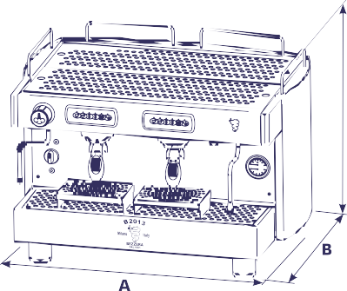
- Fully-Automatic:4 different coffee doses can be programmed for each group

- Thermostatically controlled groups
- Copper Broiler
- Built-in volumetric motor pump connected directly to the water

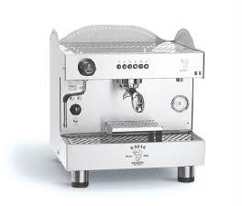
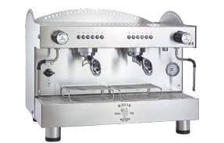
B2016DE1152
B2016DE21S4E

C



