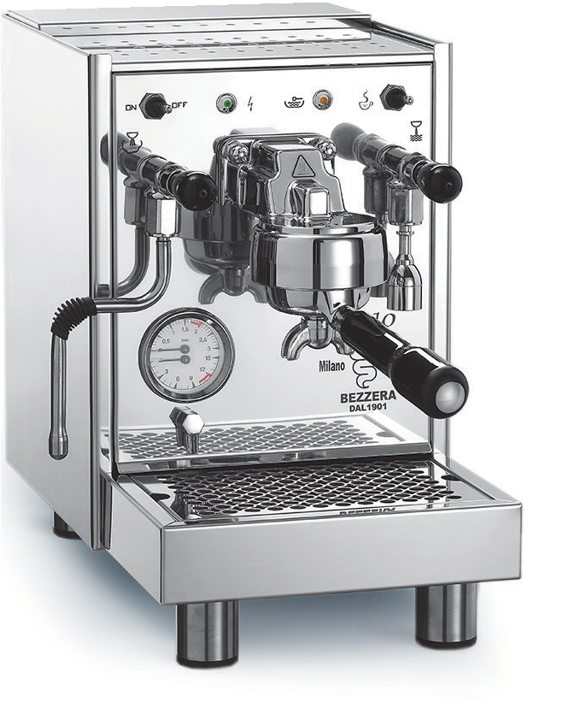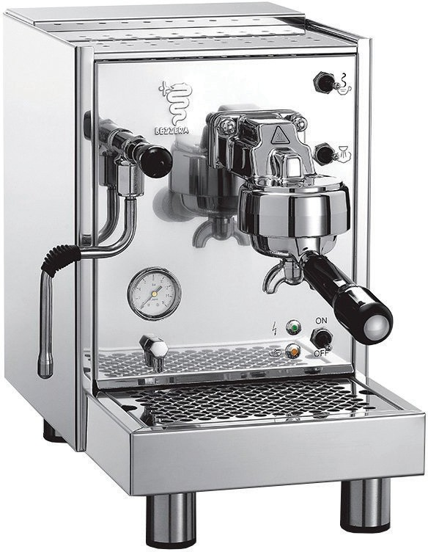

LL18SPM1IL2 (BZ10) BZ19SPM1IL2 (BZ09)

- Electrical heating
- Automatic boiler water supply
- Automatic stopping of electric resistances in case of lack of water in the boiler
- Vibration pump
- Stainless steel AISI 304 body
- No water connection needed
SPECIFICATIONS
BZ19SPM1IL2 (BZ09)
LL18SPM1IL2 (BZ10)
- Steam and hot water brewing through steam wand with lever tap
- Coffee temperature adjustable by inner thermostat
- Coffee pressure gauge
- Water tank and vibration pump
- Stainless steel AISI 304 body
- No water connection needed


SEMI PROFESSIONAL ESPRESSO COFFEE MACHINES

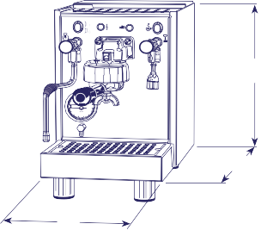
C
B
A
Voltage | 110V /50-60 Hz
Power | 1,200W
Boiler | 1.5 Liters (0.4 gal.)
Tank | 3 Liters (0.8 gal.)
Product Dimensions | 9.84” (A) x 16.7” (B) x 14.7” (C)
Net weight | 42 lbs
Shipping Dimensions | 21” (A) x 16” (B) x 18” (C)
Gross weight | 48.5 lbs


www.ampto.com 21

