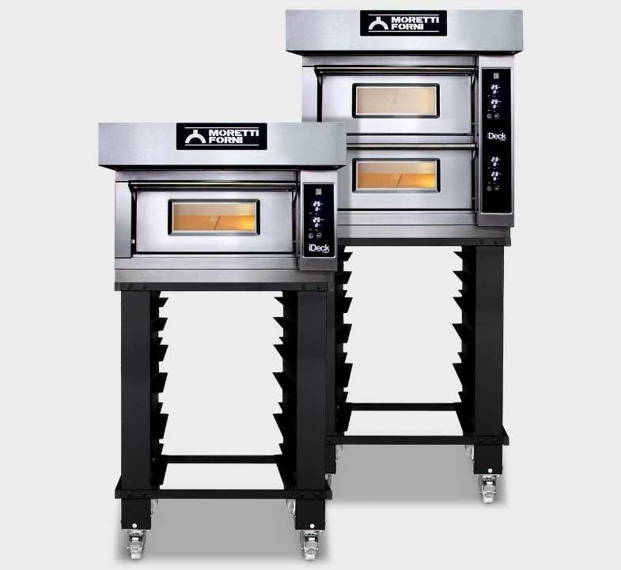

FUNCTIONING

Electric deck oven for pizza
2 decks composition
iDeck consists of one or two baking chambers and an optional prover or stand. The oven’s baking surface is made of refractory material, providing the perfect heat distribution over the whole surface. This oven is particularly suitable for direct or indirect pizza baking. Temperature management is electronic, power control of ceiling and floor is independent. The oven door is hinged at the bottom, with a tempered glass window to check the product during baking. The stand consists of a painted metal structure, while the prover is a stainless steel cabinet equipped with a heating thermostat. The prover can reach the maximum temperature of 65°C(149°F), whereas the maximum temperature of the baking chamber is 450°C (842°F).
- Heating by armoured heating elements
- Electronic power management with independent adjustment of ceiling and floor (Dual-Power TechnologyTM)
- Maximum temperature reached 450°C
- Continuoustemperature monitoring with thermocouples

CONSTRUCTION
- Front structure made in folded stainless steel
- Oven panels made pre-painted metal sheets
- Door in stainless steel with shutter with hinge at bottom with balancing spring
- Door handle in stainless steel
- Tempered crystal glass
- Control panel on the right front side
- Baking surface in refractory brick
- Upper and lateral structure in aluminized sheet
- Thermal insulation in mineral wool

BAKING ELEMENT INTERNAL DIMENSIONS
STANDARD EQUIPMENT
- Illumination by halogen lamp
- Independent maximum temperature safety device (only electronic version)

ACCESSORIES
- Prover on wheels height 700, 1000 mm
- Stand height 600, 900 mm
- 4 wheels kit
- Additional trayholder slides
- Stacking kit
- Hood

TOP VIEW

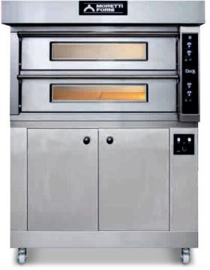
Internal height Internal depth Internal width Baking surface
140 mm
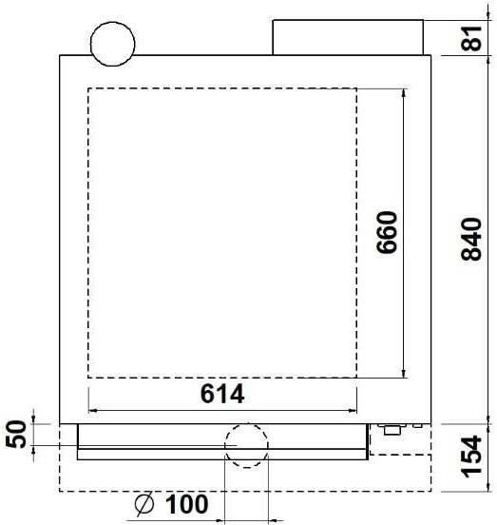
660 mm
614 mm
0,4 m2

Optional: Stainless steel cabinet Prover on wheels

iD-M 60.60
(assembled with stand height 950mm)

REAR VIEW RIGHT VIEW FRONT VIEW
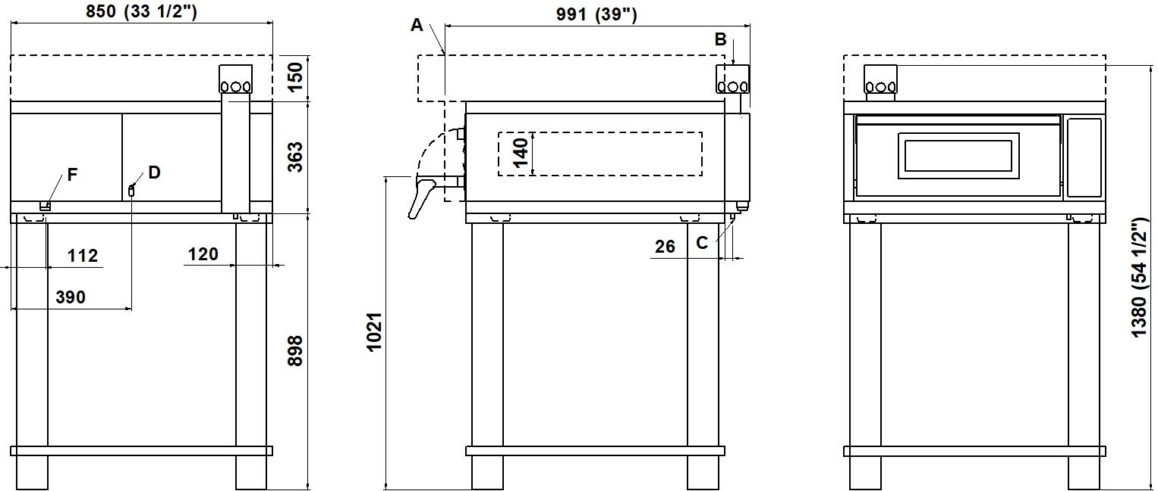

NOTE: The dimensions indicated in the views are in millimeters.

A  Ø100  hood steam collector | B  Ø INT. 102  steam exhaust | C  Ø12  condensate exhaust | D  M6  equipotential screw
F

fairleads

EXTERNAL DIMENSIONS |  | SHIPPING INFORMATION |  | FEEDING AND POWER
External height | 481 mm | Packed oven sizes: |  | Feeding AC V230 1ph
External depth | 991 mm | Height | 560 mm | Frequency 50/60Hz
External width | 850 mm | Depth | 1060 mm
Weight | 80 kg | Width | 920 mm
 |  | Weight | (80+13)kg
TOTAL BAKING CAPACITY |  |  |  | Max power  *Average power cons | 4,2 kW  2,1 kWh
Tray (600x400)mm | 1 Connecting cable recommen |  |  |  | ded (not
Pizza diameter 300mm | 4 included)
Pizza diameter 450mm | 1 Nema 6-30P 3 X AWG 10(V2 |  |  |  | 30 1ph)

Prover power supply (optional)
A.C. V230 1N 50/60 Hz
Max power 1kW
*Average power cons 0,5 kWh Connecting cable recommended (not included)
Nema 15-20P 3 X AWG 10(V230 1)
* This value is subject to variation according to the way in which the equipment is used
NOTE: MORETTI FORNI S.P.A. reserves the right to modify the characteristics of the products illustrated in this publication without prior notice

iD-D 60.60
(assembled with stand height 900mm)

REAR VIEW RIGHT VIEW FRONT VIEW
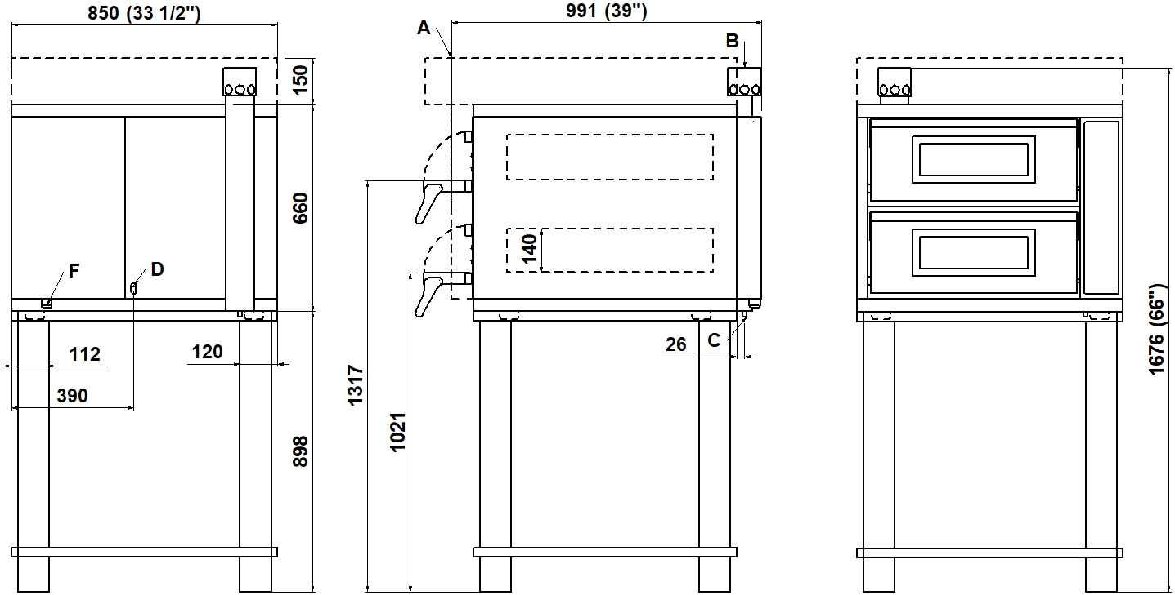

NOTE: The dimensions indicated in the views are in millimeters.

A  Ø100  hood steam collector | B  Ø INT. 102  steam exhaust | C  Ø12  condensate exhaust | D  M6  equipotential screw
F

fairleads

EXTERNAL DIMENSIONS |  | SHIPPING INFORMATION | FEEDING AND POWER
External height | 778 mm | Packed oven sizes: | Feeding
External depth | 991 mm | Max height 840 mm | A.C. V230 3ph or 1ph
External width | 850 mm | Max depth 1060 mm | To be changed on site
Weigth | 133 kg | Max width 920 mm
 |  | Weight (133+14) kg | Frequency | 50/60 Hz
TOTAL BAKING CAPACITY |  |  | Max power  *Average power cons | 8,4 kW  4,2 kWh
Tray (600x400)mm | Connecting cable recom  2 included) |  |  | mended (not
Pizza diameter 300mm | 8 Nema 6-50P 3 X AWG 6(V |  |  | 230 1ph)
Pizza diameter 450mm | 2 Nema 15-30P 4 X AWG10 |  |  | (V230 3ph)
Prover power supply (optional)
A.C. V230 1N 50/60 Hz
Max Power 1 kW
Average power cons. 0.5 kWa Connecting cable recommended (not included)
Nema 15-20P 3 X AWG 10(V230 1)
* This value is subject to variation according to the way in which the equipment is used
NOTE: MORETTI FORNI S.P.A. reserves the right to modify the characteristics of the products illustrated in this publication without prior notice

