MODEL: PROJECT: ITEM #: QTY:

PRODUCT IMAGE STANDARD FEATURES
- Heavy-Duty spout with double O-Ring construction and welded
shoulder for durability
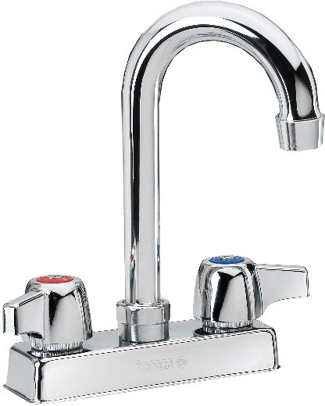
- High precision machining and polished nickel chromium finish
- Color-coded handles
- Optional wrist blade handles available
- Full replacement parts available
- Mounting kit included
- Low Lead Compliance
“L” Models meet California AB-1953 and Vermont S152 standards
11-400 SHOWN
ALSO AVAILABLE IN LOW LEAD BY ADDING “L” TO MODEL NUMBER

SPECIFICATIONS
- 4” on center deck mount with 1/2” NPT male inlets
- Rough in: Two 7/8” round holes on 4” centers
- Flow rate: 2 GPM max
- Shipping weight: 3 lbs.
- Quantity per case: 20

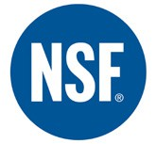
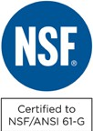
CERTIFICATIONS:

APPROVED BY:
Due to our commitment to continued product improvement, specifications are subject to change without notice.

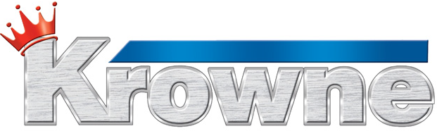
Printed in the USA

Krowne Metal Corporation
100 Haul Rd. Wayne, NJ 07470 • Toll Free: (800) 631-0442 • Fax: (973) 872-1129
sales@krowne.com • www.krowne.com • www.facebook.com/KrowneMetal • www.twitter.com/KrowneMetal
Rev. 05/2012 No. 11-4XX

MODEL: PROJECT: ITEM #: QTY:

MODELS

STANDARD SPOUTS

Model Numbers | Ⓐ | Ⓑ | Ⓒ
11-406  11-412  11-450* | 6”  12”  6” | 1 7/8”  2 5/8”  1 7/8” | 4 3/8”  5 1/8”  4 3/8”
NOTE: Add “L” to end of Model Number for Low Lead Model
*Laundry Faucet includes spout adapter

GOOSENECK SPOUTS

Model Numbers | Ⓓ | Ⓔ | Ⓕ
11-400 | 3 1/2” | 5 3/8” | 8”
NOTE: Add “L” to end of Model Number for Low Lead Model

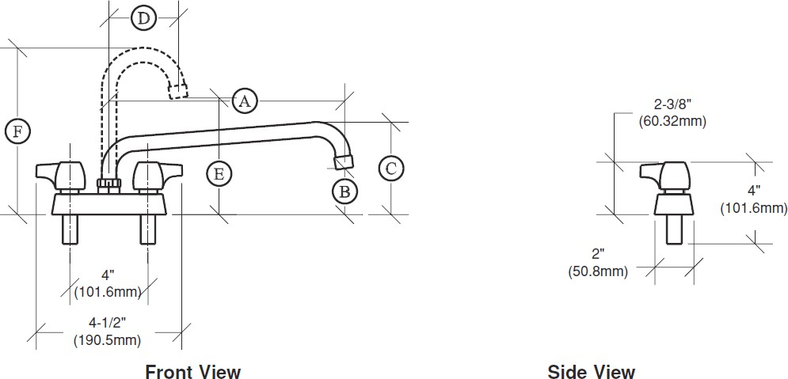
DRAWING
APPROVED BY:

CERTIFICATIONS:
Due to our commitment to continued product improvement, specifications are subject to change without notice.

Printed in the USA

Krowne Metal Corporation
100 Haul Rd. Wayne, NJ 07470 • Toll Free: (800) 631-0442 • Fax: (973) 872-1129
sales@krowne.com • www.krowne.com • www.facebook.com/KrowneMetal • www.twitter.com/KrowneMetal
Rev. 05/2012 No. 11-4XX

