
Model: 12-525L Item #: Project: Qty:

Date: Approved By:

4” Deck Mount Single Lever Faucet with Pop-Up Drain Silver Series

DESCRIPTION

PRODUCT COMPLIANCE
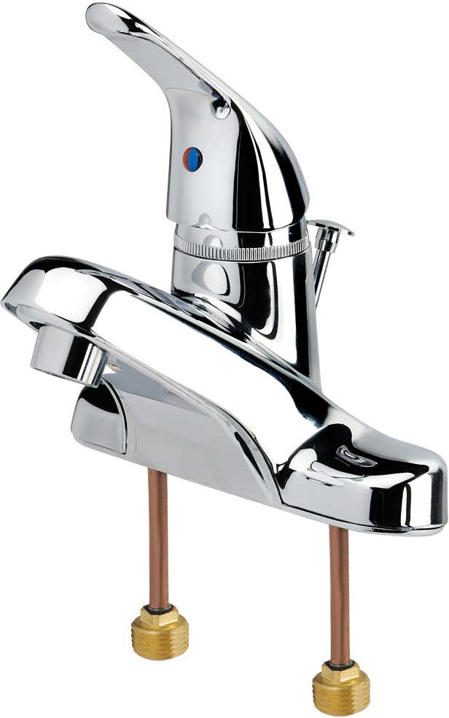
- NSF-61 & NSF/ANSI 372


- ASME A112.18.1-2011/CSA B125.1-11 & NSF/ANSI 372
- Meets ANSI A117.1 (ADA)
- Massachusetts Approved
- CEC Approved
- 4” Deck Mount Single Lever Faucet with Pop-Up Drain, Polished Chrome Finish,
0.5 GPM Male Aerator Installed, 1.5 GPM Aerator Included

STANDARD FEATURES
- Ceramic cartridge valve
- All metal constuction pop-up drain included
- Single lever handle
- Red/blue color indicator
- Warranty: 1 year
SPECIFICATIONS
Water Inlet | 1/2” NPS Male w/ Copper Tubing
Temp. Range | 40°F - 180°F
Pressure | 20-120 PSI
Rough In | 7/8” Round Holes on 4” Center
Flow Rate | 0.5 GPM
Material | Brass Underbody
Finish | Polished Chrome
Weight | 2.5 lbs.

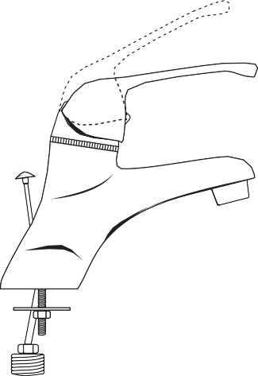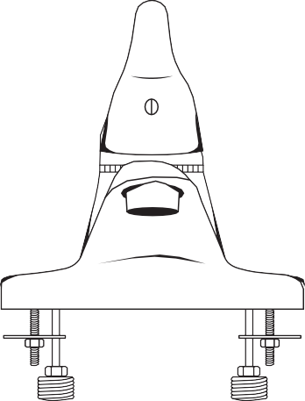
4”
Pop-Up Drain
7 1/4”
5 1/2”
3”
1-1/2”
3”
4”
4”
6”

8 1/2”

WARNING: Plumbing connections should be made by qualified personnel who will observe all applicable plumbing, sanitary and safety codes. California Proposition 65 Warning

Krowne Metal Corporation • 100 Haul Rd. Wayne, NJ 07470 • P: (800) 631-0442 • customerservice@krowne.com • krowne.com
Due to our commitment to continued product improvement, specifications are subject to change without notice. Rev. 04/2021 • No. 12-525L

