NBR faucets, the most requested product line yet, is in stock and available now!!!
available now with special introductory pricing! discount: 50/5

Twist & Lever Handle Waste Drains
Service Sink Faucet
8” Center Wall-Mount
Faucet Sets

Model # | Faucet | List Price
P2SV | 8” O.C. | $250

Model # | List Price
P3W8-PU | $440

Model # | Handle | List Price
P5LD1 | Lever | $95
P5TD1 | Twist | $95


8” Center Wall-Mount Faucets
8” Center Wall-Mount Faucet Sets With Swing Spout Add-On





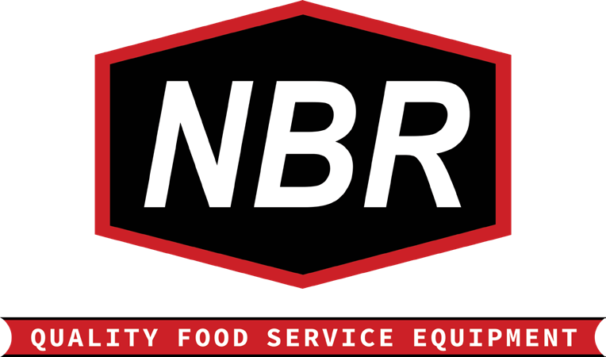
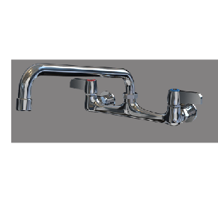
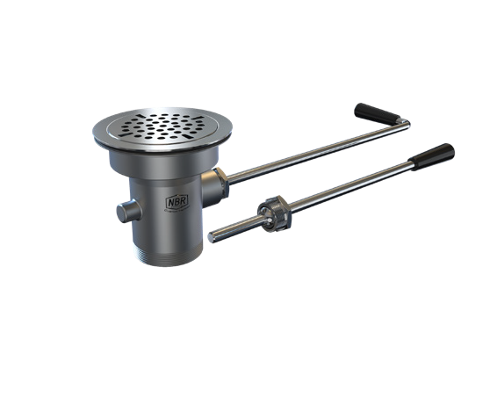
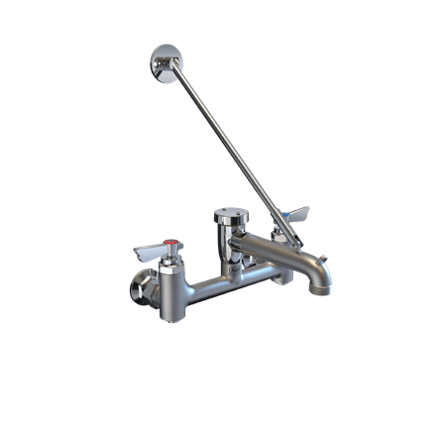
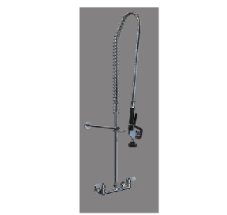
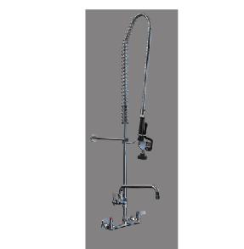



Model # | Spout Size | List Price
P3W8S6 | 6” | $113
P3W8S8 | 8” | $116
P3W8S10 | 10” | $118
P3W8S12 | 12” | $120
P3W8S14 | 14” | $122
P3W8S16 | 16” | $124

Model # | Spout Size | List Price
P3W8S6-PU | 6” | $520
P3W8S8-PU | 8” | $523
P3W8S10-PU | 10” | $525
P3W8S12-PU | 12” | $527
P3W8S14-PU | 14” | $529
P3W8S16-PU | 16” | $531

(609) 642-8389 \ sales@nbrequipment.com \ www.nbrequipment.com
NBR equipment, 10 abeel road, cranbury, Nj 08512

