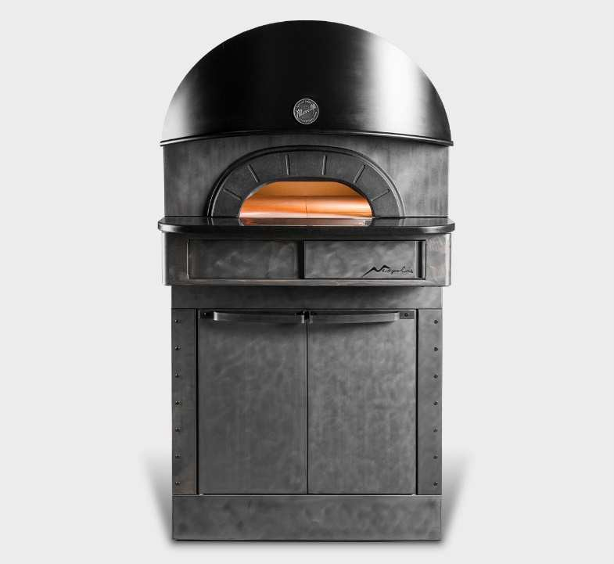

FUNCTIONING

Electric pizza oven
Neapolis consists of a baking unit and a prover. The baking surface is made of “Biscotto” brick, which ensures the perfect heat distribution in all baking areas, making this oven particularly suitable for Neapolitan pizza. Electronic temperature management, independent power control of ceiling and floor coiled heating elements. The oven is equipped with a high- insulated removable door to close its mouth. The maximum baking temperature is 950°F. The prover is made of a painted steel structure, featuring castor wheels with safety break not at sight. Prover maximum temperature is 150°F.
- Heating via bare-wire coil resistors with optimised
temperature balancing
- Maximum temperature of 950°F
- Patented Self-stabilising internal deflectors situated on dome
oven chamber surface to minimise leakage and ensure uniform heat distribution
- Electronic temperature management with independent
adjustment of ceiling and floor
- Continuous temperature monitoring with thermocouple
- Steam draught adjustable via a manual valve

STANDARD EQUIPMENT
- Removable oven chamber stainless-steel door, with increased
insulation and heat-resistant handle
- Stainless-steel door supports
- Protected lighting thanks to hidden double halogen lamps
- Lateral refractory protection in oven chamber opening
- Daily power-on timer
- ECO-STAND BY TECHNOLOGY™ for work breaks
- 20 customisable programs
- Pre-set programs: temperature rises, average setting,
maximum setting, heat-regulation cleaning
- Separate max. temperature safety device
- Anchoring system for lifting
- Heat-regulated Proofer with internal lighting and hidden
controllable castor wheels

EXTERNAL CONSTRUCTION
- Sheet steel structure coated with high-temperature epoxy
powder paint finish
- External panelling with "post-industrial" finish
- ”Inox Vintage” coated front panel
- Black granite landing with slot for thermal bridge break
- Cast-iron oven opening
- Rounded fume hood with Neapolis® design
- Black coated stainless steel cylindrical flue
- Front-facing digital control panel and retractable sliding panel

INTERNAL CONSTRUCTION
- Oven chamber made from refractory material
- 2 3/8” thick patented slab with interchangeable 'Biscuit' baking
surface positioned on top of heating plate made from perforated refractory material
- Resistor inserted inside the ceiling and floor perforated
refractors
- Patented High-density dual insulation for high temperatures
- Insulation with heated joints and a COOL AROUND®
TECHNOLOGY air space

ACCESSORY TO BE PURCHASED AS OPTIONAL
- Tray holder slides for Proofer
- Heavy Duty Pack for internal oven chamber protection
- Stainless steel door with a special high-temperatures-resistant
glass for long baking
- Specific pizza peel and turning peel for Neapolis
- Peel holder with stand for removable door

Neapolis 6
(assembled with Proofer height 41 1/2”)
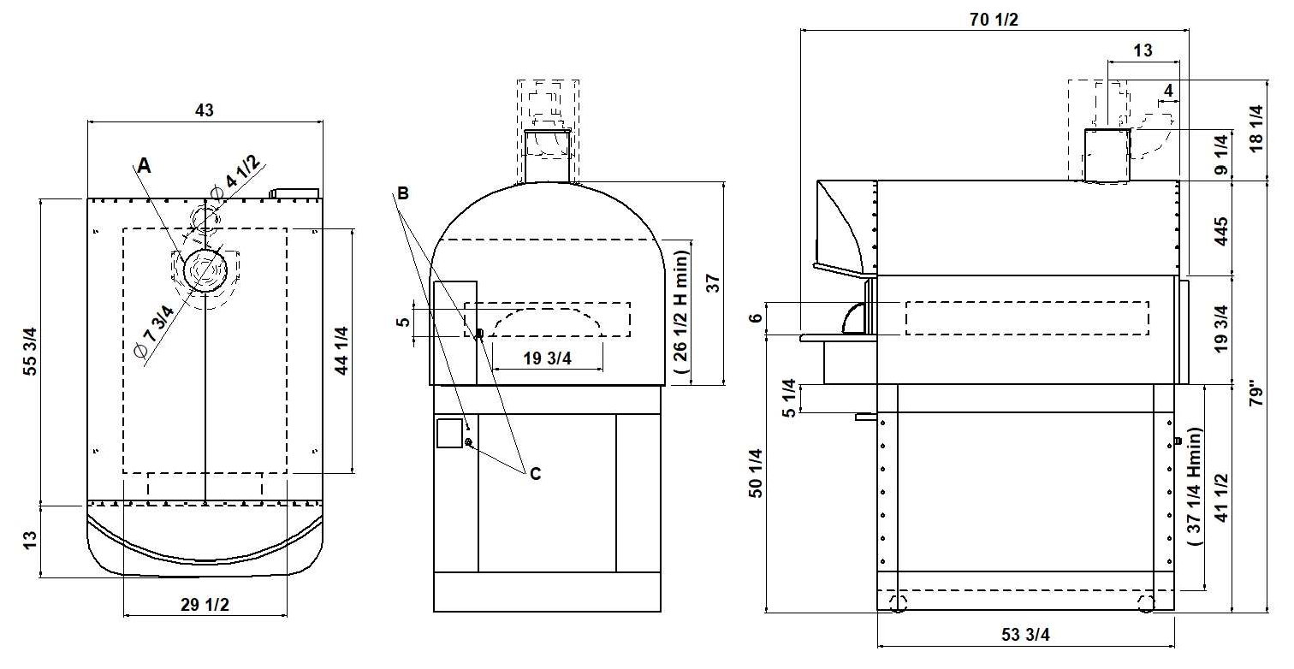
TOP VIEW REAR VIEW RIGHT SIDE VIEW
NOTE: The dimensions shown in these diagrams are in inches.
A
steam exhaust
B
M6
equipotential screws
C
fairleads

EXTERNAL DIMENSIONS
External height 79” (1995mm) External depth 70 1/2” (1786mm) External width 43” (1084mm)
Weight 1160lb (525kg)

INTERNAL DIMENSIONS
Internal height 5 7/8” (150mm) Internal depth 44 9/32” (1125mm) Internal width 29 1/2” (750mm) Baking surface (9ft2) (0.84mq2)

TOTAL BAKING CAPACITY
Pizza diameter 13” 6

PROOFER CAPACITY
Container inch(23x15 H2 3/4) max 12
Container inch(23x15 H4) max 12
Container inch(23x15 H5) max 12
SHIPPING INFORMATION
Packed in wooden crate
Height 87” (2200mm)
Depth 77” (1940mm)
Widht 51” (1280mm)
Weight 1427lb (646kg)

In case of separate packaging for aerial shipments:
Oven
Height 52” (1300mm)
Depth 75” (1940mm)
Widht 51” (1280mm)
Weight 1040lb (470kg)

Proofer
Height 52” (1300mm)
Depth 75” (1940mm)
Widht 51” (1280mm)
Weight 445lb (200kg)
FEEDING AND POWER FEEDING AND POWER (EACH DECK NEEDS TO BE CONNECTED INDEPENDENTLY AND THE LOAD SHOWN BELOW ARE PER DECK)

Standard feeding
A.C. V240 3ph
Feeding on request
A.C. V208 3ph
Frequency 60Hz
Max power 14,35kW/DECK
*Average power cons 6,5kWh Ampère Max
34,5A/DECK (V240 3ph)
39,9A/DECK (V208 3ph)
Connecting cable
(8AWG/DECK)

Power supply Proofer
A.C. V(208/240) 1ph 60 Hz
Max power 1.8kW
*Average Power cons. 0.9kWh (14AWG - Ampère Max 7,5A)

*This value is subject to variation according to the way in which the equipment is used
NOTE: MORETTI FORNI S.P.A. reserves the right to modify the characteristics of the products illustrated in this publication without prior notice

