Modular electric deck oven
2 decks composition
serieP consists of one or more independent baking chambers and an optional prover or stand. The baking surface is made of refractory stone with coiled heating elements inside, allowing the perfect heat distribution over the whole surface. This oven is particularly suitable for direct pizza baking, on floor or on trays. Embossed stainless steel surface combined with steamer (optional) is available as an alternative to refractory stone and it is especially recomended for bakery. The baking chamber comes in two heights: 18cm or 30 cm. Temperature management is electronic, power control of ceiling and floor is independent. The oven door is hinged at the bottom, with a tempered glass window to check the product during baking. The stand consists of a painted metal structure, while the prover is a stainless steel cabinet equipped with a heating thermostat. The prover can reach the maximum temperature of 149°F, whereas the maximum temperature of the baking chamber is 842°F.


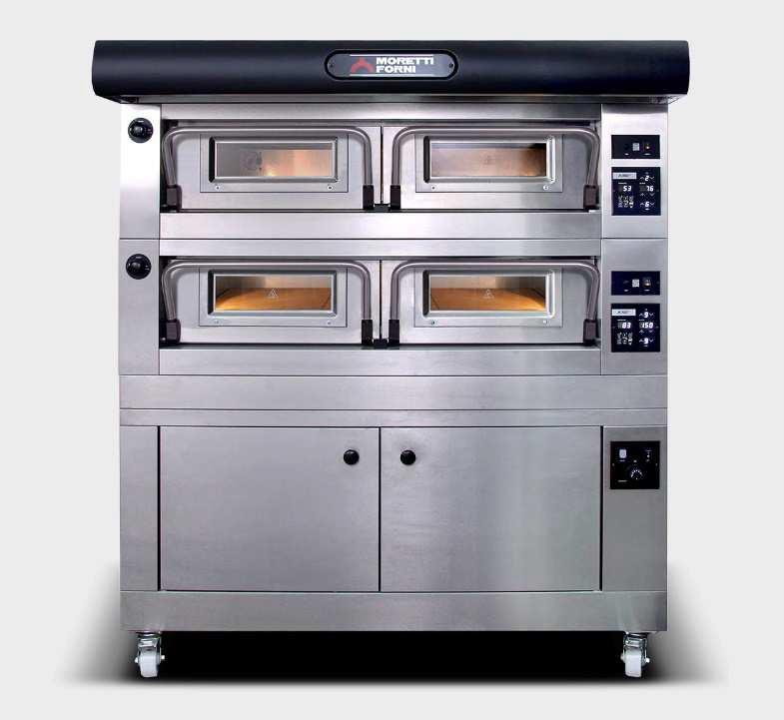

OPERATION
- Heated by armoured heating elements
- Electronic temperature management with independent adjustment of ceiling
and floor
- Maximum temperature reached 842°F
- Continuous temperatures monitoring in baking chamber by thermocouple
- Vapour ducting using manual butterfly valve

CONSTRUCTION
- Structure made in folded stainless steel
- Side panels in painted sheet metal
- Hood in stainless steel
- Steam duct in stainless steel plate
- Stainless steel door, tempered glass
- Aluminated steel top and side structure
- Dual halogen lighting
- Rock wool heat insulation

ACCESSORIES
- Leavening prover on wheels height 31 1/2”
- Stand with wheels height 23 1/2”, 31 1/2”, 37 1/2”
- Steamer
- Spacer element height 11 13/16”
- Refractory brick or buckle plate surface
- Additional tray holder guides for compartment and stand
- Self-condensing hood
- Frontless hood

INTERNAL BAKING DIMENSIONS
Internal height 7”/12”
Internal depth 51”
Internal widht 49”
Baking surface 17,2ft2
STANDARD EQUIPMENT
- 20 customisable programs
- Timer
- Economiser
- Independent maximum temperature safety device

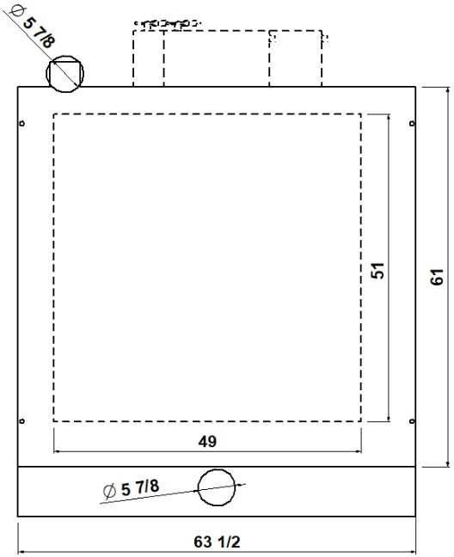
TOP VIEW

1 baking chamber height 7”
(assembled with stand height 37 1/2”)

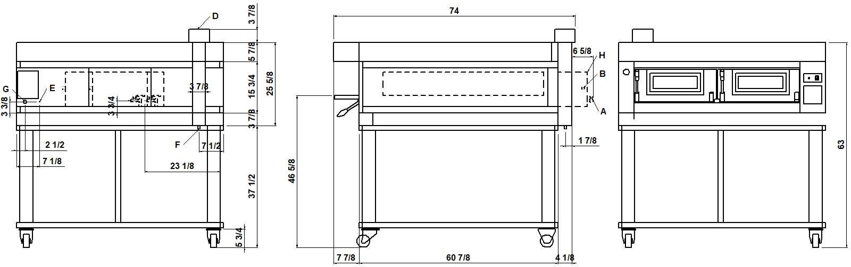
REAR VIEW RIGHT SIDE VIEW FRONT VIEW

NOTE: The dimensions indicated in the views are in inches.

A  Ø 5/16”  steamer water outlet | B  3/4” male steamer water inlet | D  Ø 5 7/8”  steam exhaust | E  M6  equipotential screws
F  Ø 1/2”  condensate exhaust | G  fairleads | H  Steamer 3480W (see data sheet)

DIMENSIONS
External height 25 5/8” (650mm) External depth 61” (1547mm) External width 63 1/2” (1610mm) Weight 763lb (346kg)

TOTAL BAKING CAPACITY
Tray 26”x18” (600x400)mm 6
Pizza diameter 12” 16
Pizza diameter 18” 6
SHIPPING INFORMATION
Packed in wooden crate
Height 36” (900mm)
Depth 81” (2052mm)
Width 72” (1810mm)
Weight 874lb (396kg)

When combined with leavening compartment or stand:
Max height 73” (1850mm)
Max weight 1142lb (518kg)

FEEDING AND POWER
Standard feeding
A.C. V240 3ph
Feeding on request
A.C. V208 3ph
Frequency 60Hz
Max power 16,9kW/DECK
*Average power cons 8,5kWh Ampère max
40,7A/DECK (V240 3ph)
46,9A/DECK (V208 3ph)
Connecting cable for each chamber
9AWG/DECK
Power supply (optional proofer)
A.C. V(208/240) 1ph 60Hz
Max power 1,8kW
*Average power cons 0,9kWh Conn. Cable 14AWG – Ampère 7,5A

* This value is subject to variation according to the way in which the equipment is used
NOTE: MORETTI FORNI S.P.A. reserves the right to modify the characteristics of the products illustrated in this publication without prior notice

REAR VIEW RIGHT SIDE VIEW FRONT VIEW
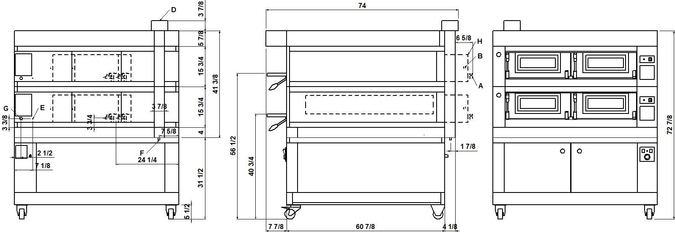

NOTE: The dimensions indicated in the views are in inches.

A  Ø 5/16”  steamer water outlet | B  3/4” male steamer water inlet | D  Ø 5 7/8”  steam exhaust | E  M6  equipotential screws
F  Ø 1/2”  condensate exhaust | G  fairleads | H  Steamer 3480W (see data sheet)

DIMENSIONS
External height 41 3/8” (1050mm) External depth 61” (1547mm) External width 63 1/2” (1610mm) Weight 1281lb (581kg)

SHIPPING INFORMATION
Packed in wooden crate
Height 51 1/2” (1300mm)
Depth 81” (2052mm)
Width 72” (1810mm)
Weight 1414lb (641kg)
TOTAL BAKING CAPACITY
Tray 26”x18” (600x400)mm | 12
Pizza diameter 12” | 32
Pizza diameter 18” | 12

When combined with leavening compartment or stand:
Max height 89” (2250mm)
Max weight 1683lb (763kg)

FEEDING AND POWER
Standard feeding
A.C. V400 3N
Feeding on request
A.C. V230 3
Frequency 50/60Hz
Max power 31,0kW
*Average power cons 15,6kWh Connecting cable for each chamber
type H07RN-F 5x6mm2 (V400 3N)
4x10mm2 (V230 3)
Power supply (optional prover)
A.C. V230 1N 50/60 Hz
Max power 1,5kW
*Average power cons 0,8kWh Conn. Cable type H07RN-F 3x1,5mm2
* This value is subject to variation according to the way in which the equipment is used
NOTE: MORETTI FORNI S.P.A. reserves the right to modify the characteristics of the products illustrated in this publication without prior notice

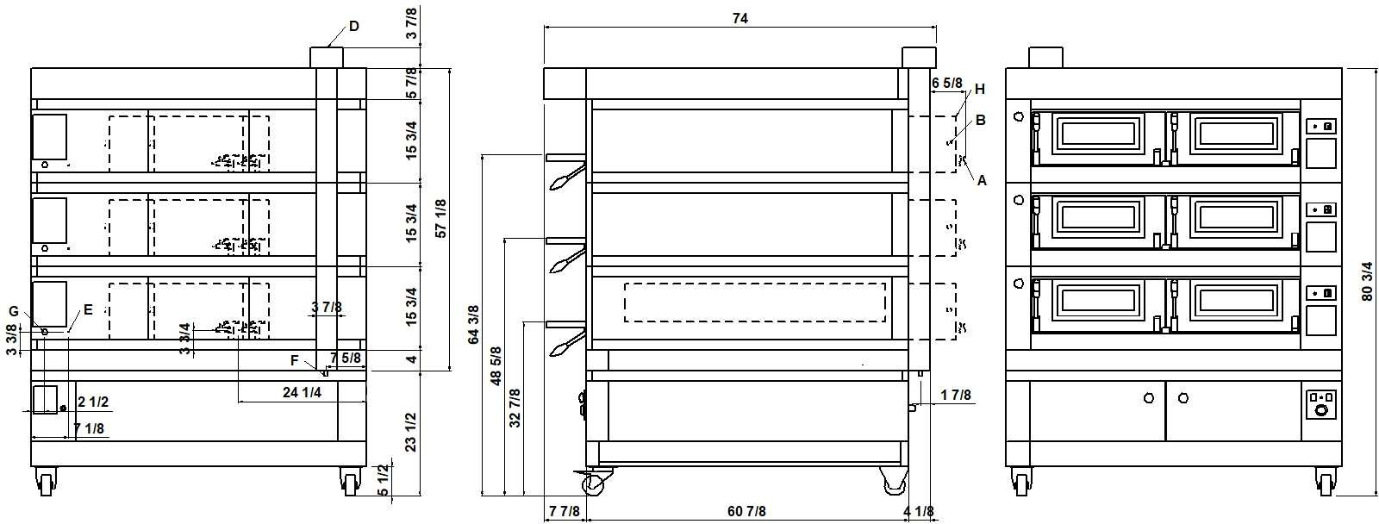
REAR VIEW RIGHT SIDE VIEW FRONT VIEW

NOTE: The dimensions indicated in the views are in inches.

A  Ø 5/16”  steamer water outlet | B  3/4” male steamer water inlet | D  Ø 5 7/8”  steam exhaust | E  M6  equipotential screws
F  Ø 1/2”  condensate exhaust | G  fairleads | H  Steamer 3480W (see data sheet)

DIMENSIONS
External height 57 1/8” (1450mm) External depth 61” (1547mm) External width 63 1/2” (1610mm) Weight 1799lb (716kg)

SHIPPING INFORMATION
Packed in wooden crate
Height 67” (1700mm)
Depth 81” (2052mm)
Width 72” (1810mm)
Weight 1954lb (886kg)
TOTAL BAKING CAPACITY
Tray 26”x18” (600x400)mm | 18
Pizza diameter 12” | 48
Pizza diameter 18” | 18

When combined with leavening compartment or stand:
Max height 105” (2650mm)
Max weight 2223lb (1008kg)

FEEDING AND POWER
Standard feeding
A.C. V400 3N
Feeding on request
A.C. V230 3
Frequency 50/60Hz
Max power 46,5kW
*Average power cons 23,4kWh Connecting cable for each chamber
type H07RN-F 5x6mm2 (V400 3N)
4x10mm2 (V230 3)
Power supply (optional prover)
A.C. V230 1N 50/60 Hz
Max power 1,5kW
*Average power cons 0,8kWh Conn. Cable type H07RN-F 3x1,5mm2
* This value is subject to variation according to the way in which the equipment is used
NOTE: MORETTI FORNI S.P.A. reserves the right to modify the characteristics of the products illustrated in this publication without prior notice

2 baking chambers height 7”+12”
(assembled with proofer height 31 1/2”)

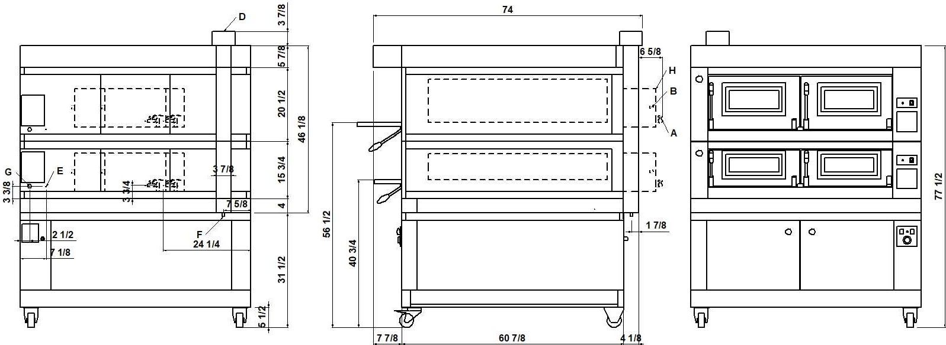
REAR VIEW RIGHT SIDE VIEW FRONT VIEW

NOTE: The dimensions indicated in the views are in inches.

A  Ø 5/16”  steamer water outlet | B  3/4” male steamer water inlet | D  Ø 5 7/8”  steam exhaust | E  M6  equipotential screws
F  Ø 1/2”  condensate exhaust | G  fairleads | H  Steamer 3480W (see data sheet)

DIMENSIONS
External height 46” (1170mm)
External depth 61” (1547mm) External width 63 1/2” (1610mm) Weight 1380lb (625kg)

SHIPPING INFORMATION
Packed in wooden crate
Height 56” (1420mm)
Depth 81” (2052mm)
Width 72” (1810mm)
Weight 1510lb (685kg)
TOTAL BAKING CAPACITY
Tray 26”x18” (600x400)mm | 12
Pizza diameter 12” | 32
Pizza diameter 18” | 12

When combined with leavening compartment or stand:
Max height 94” (2370mm)
Max weight 1775lb (805kg)

FEEDING AND POWER
Standard feeding
A.C. V400 3N
Feeding on request
A.C. V230 3
Frequency 50/60Hz
Max power 31,0kW
*Average power cons 15,6kWh Connecting cable for each chamber
type H07RN-F 5x6mm2 (V400 3N)
4x10mm2 (V230 3)
Power supply (optional prover)
A.C. V230 1N 50/60 Hz
Max power 1,5kW
*Average power cons 0,8kWh Conn. Cable type H07RN-F 3x1,5mm2
* This value is subject to variation according to the way in which the equipment is used
NOTE: MORETTI FORNI S.P.A. reserves the right to modify the characteristics of the products illustrated in this publication without prior notice

3 baking chambers height 7”+7”+12”
(assembled with proofer height 23 1/2”)

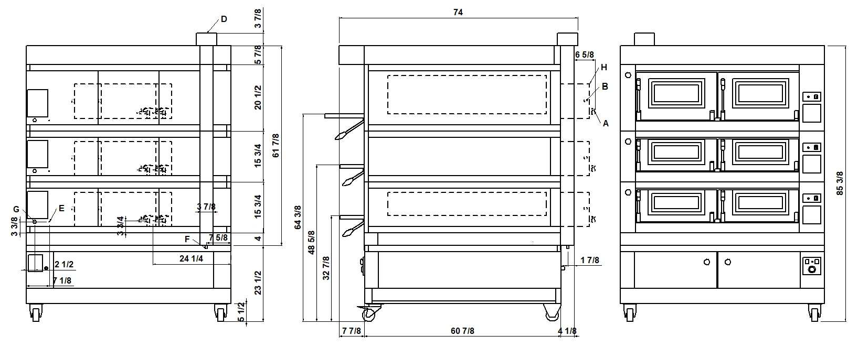
REAR VIEW RIGHT SIDE VIEW FRONT VIEW
NOTE: The dimensions indicated in the views are in inches.

A  Ø 5/16”  steamer water outlet | B  3/4” male steamer water inlet | D  Ø 5 7/8”  steam exhaust | E  M6  equipotential screws
F  Ø 1/2”  condensate exhaust | G  fairleads | H  Steamer 3480W (see data sheet)

DIMENSIONS
External height 61 7/8” (1570mm) External depth 61” (1547mm) External width 63 1/2” (1610mm) Weight 1895lb (860kg)

SHIPPING INFORMATION
Packed in wooden crate
Height 72” (1820mm)
Depth 81” (2052mm)
Width 72” (1810mm)
Weight 2050lb (930kg)
TOTAL BAKING CAPACITY
Tray 26”x18” (600x400)mm | 18
Pizza diameter 12” | 48
Pizza diameter 18” | 18

When combined with leavening compartment or stand:
Max height 109” (2770mm)
Max weight 2315lb (1050kg)

FEEDING AND POWER
Standard feeding
A.C. V400 3N
Feeding on request
A.C. V230 3
Frequency 50/60Hz
Max power 46,5kW
*Average power cons 23,4kWh Connecting cable for each chamber
type H07RN-F 5x6mm2 (V400 3N)
4x10mm2 (V230 3)
Power supply (optional prover)
A.C. V230 1N 50/60 Hz
Max power 1,5kW
*Average power cons 0,8kWh Conn. Cable type H07RN-F 3x1,5mm2

* This value is subject to variation according to the way in which the equipment is used
NOTE: MORETTI FORNI S.P.A. reserves the right to modify the characteristics of the products illustrated in this publication without prior notice

* This value is subject to variation according to the way in which the equipment is used
NOTE: MORETTI FORNI S.P.A. reserves the right to modify the characteristics of the products illustrated in this publication without prior notice
P120 C
TECHNICAL DATA

SHIPPING INFORMATION H18 |  | P120C_1_18 | P120C_2_18 | P120C_3_18
Packed in wooden crate | Height | 36” (900mm) | 51 1/2” (1300mm) | 67” (1700mm)
Packed in wooden crate | Weight | 874lb (396kg) | 1414lb (641kg) | 1954lb (886kg)
When combined with proofer or stand | Max. height | 73” (1850mm) | 89” (2250mm) | 105” (2650mm)
When combined with proofer or stand | Max. weight | 1142lb (518kg) | 1683lb (763kg) | 2223lb (1008kg)
SHIPPING INFORMATION H30 |  | P120C_1_30 | P120C_2_30 | P120C_3_30
Packed in wooden crate | Height | 41” (1020mm) | 61” (1540mm) | 82” (2060mm)
Packed in wooden crate | Weight | 917lb (416kg) | 1501lb (681kg) | 2086lb (946kg)
When combined with proofer or stand | Max. height | 78” (1970mm) | 93” (2340mm) | 113” (2860mm)
When combined with proofer or stand | Max. weight | 1186lb (538kg) | 1770lb (803kg) | 2377lb (1078kg)

FEEDING AND POWER  (EACH DECK NEEDS TO BE CONNECTED INDEPENDENTLY AND THE LOAD SHOWN BELOW ARE PER DECK) | A.C. V240 3ph 60Hz | Standard feeding | Max power | kW | 16,9
 | A.C. V240 3ph 60Hz | Standard feeding | *Medium cons/hour | kWh | 8,5
 | A.C. V240 3ph 60Hz | Standard feeding | Ampère Max | A/DECK | 40,7
 | A.C. V240 3ph 60Hz | Standard feeding | Connecting cable | AWG/DECK | 7
 | A.C. V208 3ph 60Hz | Feeding on request | Max power | kW | 16,9
 | A.C. V208 3ph 60Hz | Feeding on request | *Medium cons/hour | kWh | 8,5
 | A.C. V208 3ph 60Hz | Feeding on request | Ampère Max | A/DECK | 46,9
 | A.C. V208 3ph 60Hz | Feeding on request | Connecting cable | AWG/DECK | 7
 | A.C. V240 3ph 60Hz  pastry heating elements | Standard feeding | Max power | kW | 12,5
 | A.C. V240 3ph 60Hz  pastry heating elements | Standard feeding | *Medium cons/hour | kWh | 6,3
 | A.C. V240 3ph 60Hz  pastry heating elements | Standard feeding | Ampère Max | A/DECK | 30,1
 | A.C. V240 3ph 60Hz  pastry heating elements | Standard feeding | Connecting cable | AWG/DECK | 7
 | A.C. V208 3ph 60Hz  pastry heating elements | Feeding on request | Max power | kW | 12,5
 | A.C. V208 3ph 60Hz  pastry heating elements | Feeding on request | *Medium cons/hour | kWh | 6,3
 | A.C. V208 3ph 60Hz  pastry heating elements | Feeding on request | Ampère Max | A/DECK | 34,7
 | A.C. V208 3ph 60Hz  pastry heating elements | Feeding on request | Connecting cable | AWG/DECK | 7
 | A.C. V(208/240) 1ph 60Hz | Proofer | Max power | kW | 1,8
 | A.C. V(208/240) 1ph 60Hz | Proofer | *Medium cons/hour | kWh | 0,9
 | A.C. V(208/240) 1ph 60Hz | Proofer | Ampère Max | A/DECK | 7,5
 | A.C. V(208/240) 1ph 60Hz | Proofer | Connecting cable | AWG/DECK | 14

