

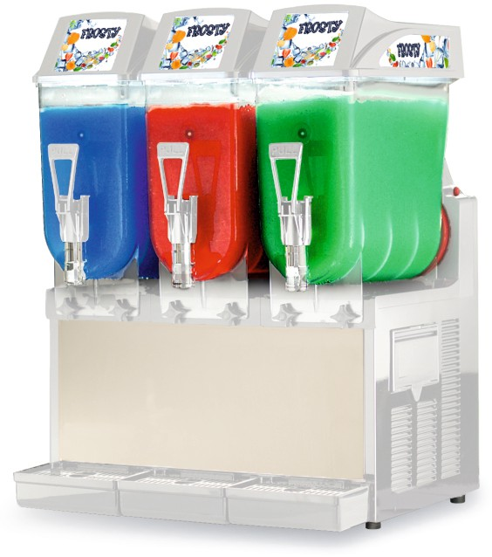

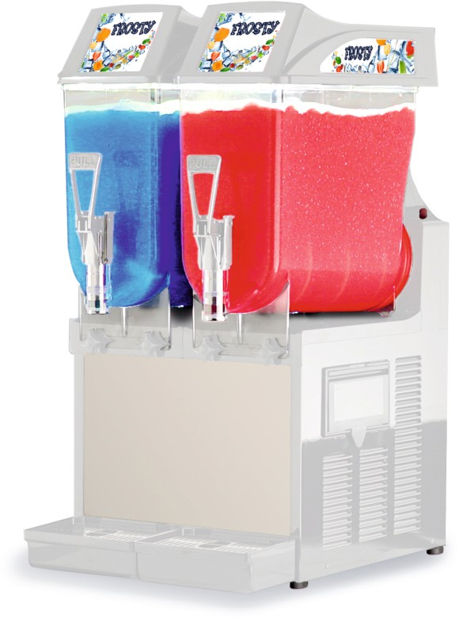
GRA-122

GRA-123

Important NOTES:
- Operate at room temperature between 75 - 90° F (24 and 32° C).
- Clearance of 8" required on all sides.
- Mixture must maintain a sugar content between 12 -14%; a lower concentration could seriously damage the mixing parts and gear motors.

- High-performance equipment, for slushes, sherbets and other frozen products
- Double mixing system prevents ice accumulation, for optimum product's consistency
- Cold light illumination with LED
- Stainless steel base: front, side, and rear
- Adjustable consistency
- Safety Stop System
- Air cooling system - Refrigerant Gas R404a
- Manual control keypad
- All models are certifi ed NSF-6 safe for milk

*Also available in special voltage 220V / 60-50 Hz
25" 0N) x 22" (D) x 33"

(H)



-MADE IN -ITALY
www.ampto.com
■

