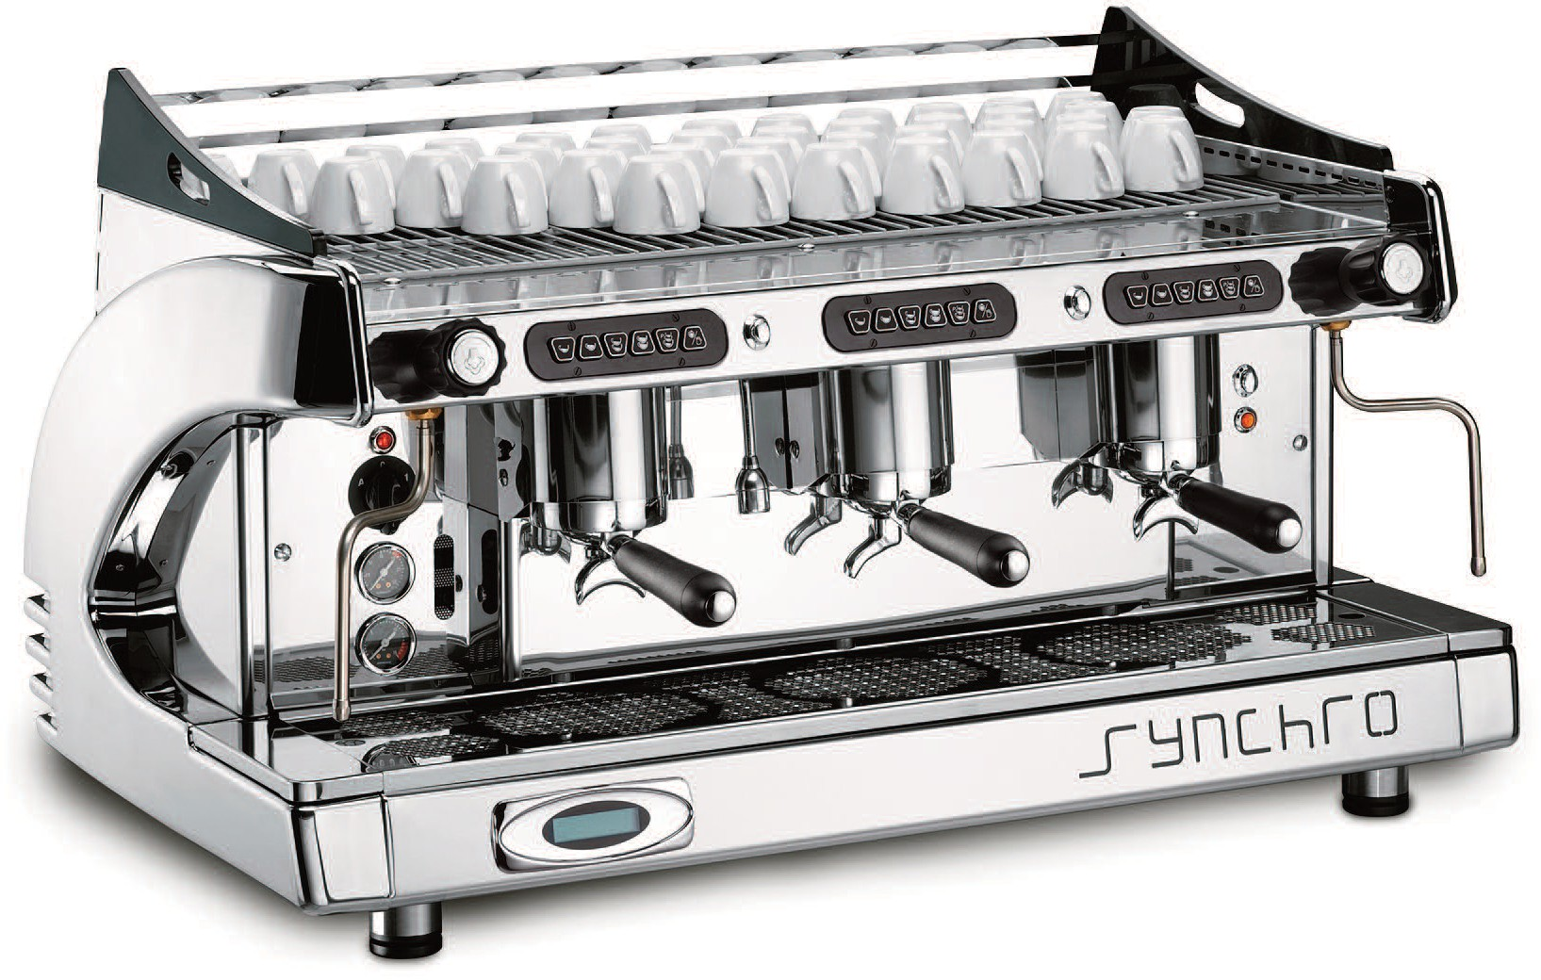
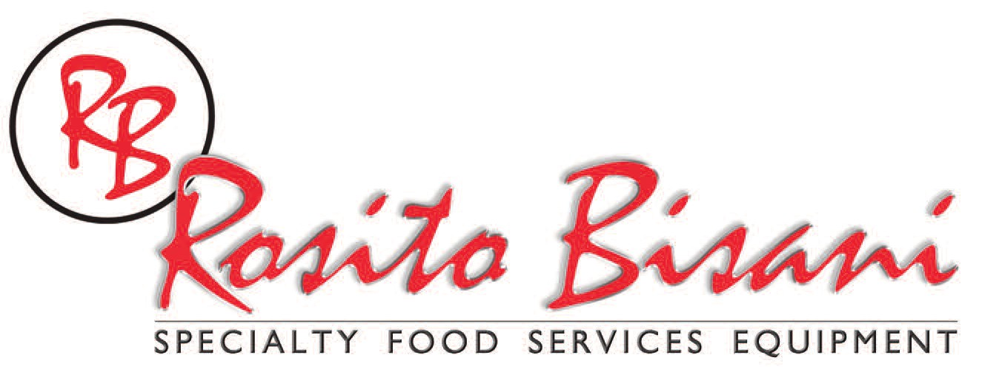
Synchro 3
3 Group Espresso Machine

STANDARD FEATURES
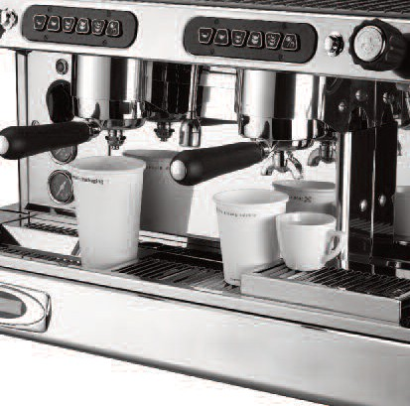
- Three group automatic espresso machine with 1-6 cup simulta- neous delivery capacity
- Volumetric touchpad with program- mable dosages
- Automatic back-flush cleaning pro- gram per group
- Independent Continuous button for semi-automatic operation
- Two Stainless Steel Swivel Steam jets
- One Stainless Steel hot water jet
- Sleek, modern, and art decorative design
- LCD Display with Variety of Programmable Parameters (Shot Timers, Date,Time, Service Info, etc)
- Classic thermal brewing group with dynamic pre-infusion ensures optimal espresso extraction
- Certified ETL, NSF

Optional
- Available Colors: Black, Red, Chrome, Orange, White
- Deep Drip Tray to Accommodate Large Take Out Cups
- APS Automatic Steam Wand for Cappuccino and Latte

ITEM: PROJECT: DATE:

Synchro 3
3 Group Espresso Machine

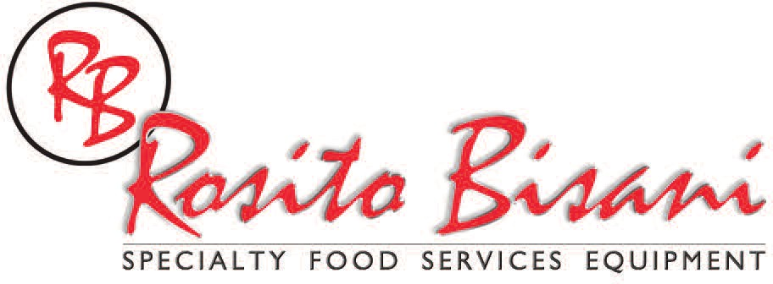
Synchro 3
3 Group Espresso Machine




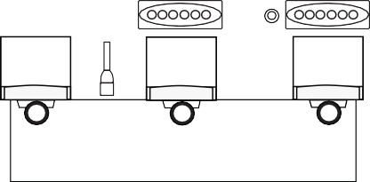

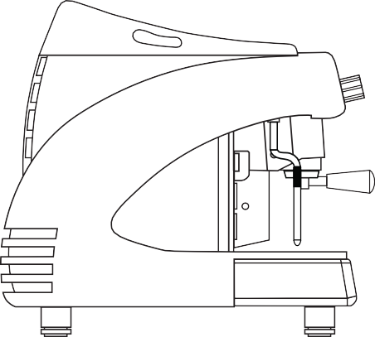
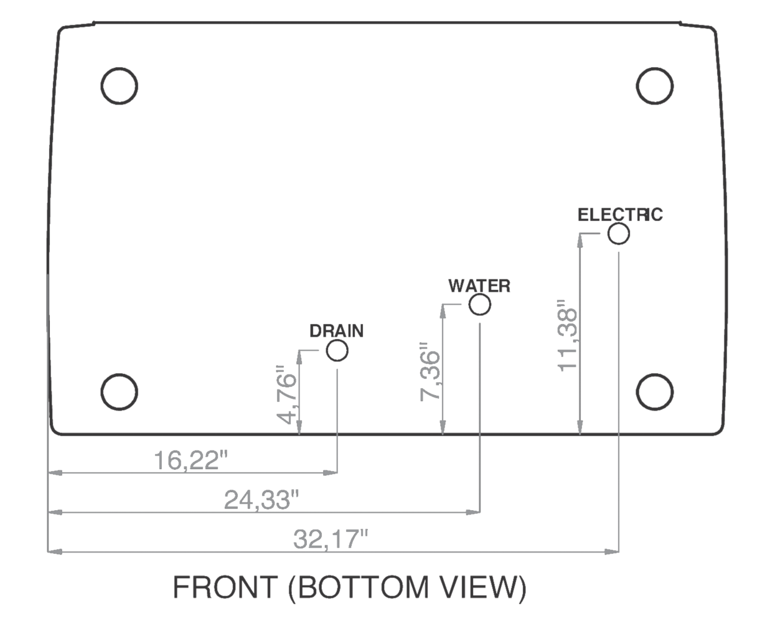
38”
23”
23.5”

BREW DEVICE | CUPS PER GROUP | W x D x H | BOILER CAPACITY  (liters) | V. | AMP. | P.H. | Hz | WATTS | WEIGHT  (Kg./Lbs.) | SHIPPING WEIGHT  (Kg./Lbs.) | INCOMING H2O | DRAIN | MIN/MAX  bar
3 | 6 | 38 x 23 x 23.5 | 21 | 220 | 21 | 1 | 60 | 4600 | 85/185 | 92/203 | 3/8” MALE | Δ9mm INTERNAL | 2 / 5
Rosito Bisani Imports, Inc.

940 South La Brea Avenue, Los Angeles CA, 90036
Tel: 323-937-1888 • Fax: 323-938-0728 • Toll Free: 1-800-848-4444
E-mail: sales@rosito-bisani.com

www.rosito-bisani.com
530 South Henderson Road, Suite F, King of Prussia PA, 19406 Tel: 610-265-5950 • Fax: 888-576-8524
E-mail: rbe@rosito-bisani.com

Rosito and Bisani Imports reserve the right to make changes in design specifications and/or to make additional improvements in it’s products without imposing any obligations upon itself to install them on products previously manufactured. © 2013.

