
_{Model:} 11-406L
Project:
Item #: Qty:
Date: Approved By:

4” Center Deck Mount Faucet with 6” Spout Royal Series Plumbing

DESCRIPTION
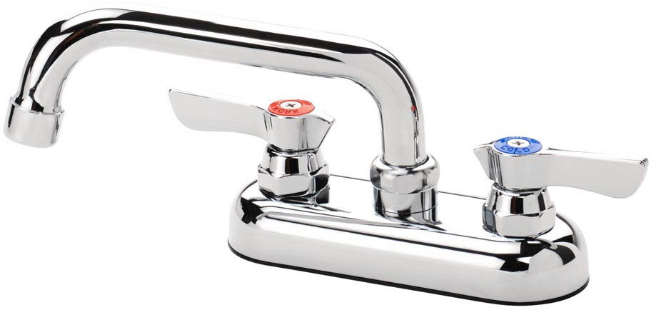
- 4” Center Deck Mount Faucet with 6” Spout, Polished Chrome Finish, 1.8GPM Aerator Installed

11-406L

STANDARD FEATURES
- ¼ Turn Ceramic Valves
- Durable Full Range Swing Spout with Double O-Ring Construction
- Lever Handles
- Warranty: 1 Year

PRODUCT COMPLIANCE
SPECIFICATIONS
Water Inlet | 1/2” NPT
Temp. Range | 40°F - 180°F
Rough In | 7/8” Round Holes on 4” Center
Flow Rate | 1.8 GPM
Material | Chrome Plated Brass
Weight | 3 lbs.



- ASME A112.18.1-2011/CSA B125.1-11
- NSF-61
- NSF/ANSI 372
- Meets ANSI A117.1 (ADA)
- California Proposition 65
- CEC Listed
- Massachusetts Approved
WARNING: Plumbing connections should be made by qualified personnel
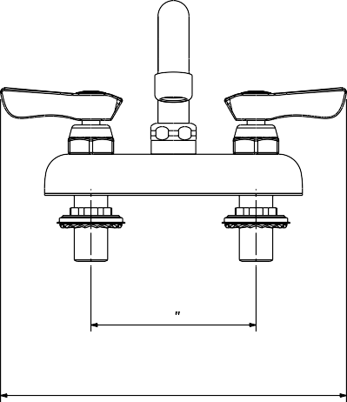
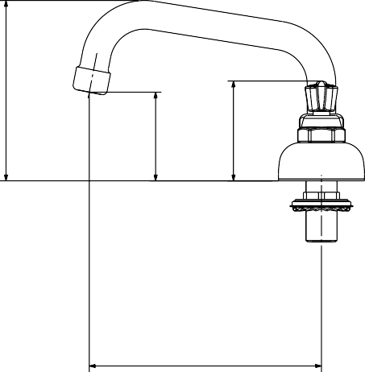
who will observe all applicable plumbing, sanitary and safety codes.
4
8 - 3/8 "
6 - 1/8 "
4 - 3/4 "
2 - 3/8 "
2 - 5/8 "

Krowne Metal Corporation • 100 Haul Rd. Wayne, NJ 07470 • Toll Free: (800) 631-0442 • Fax: (973) 872-1129 • sales@krowne.com • krowne.com

Due to our commitment to continued product improvement, specifications are subject to change without notice. Rev. 1/2020 • No. 11-406L

